CRISES MANAGEMENT PLAN
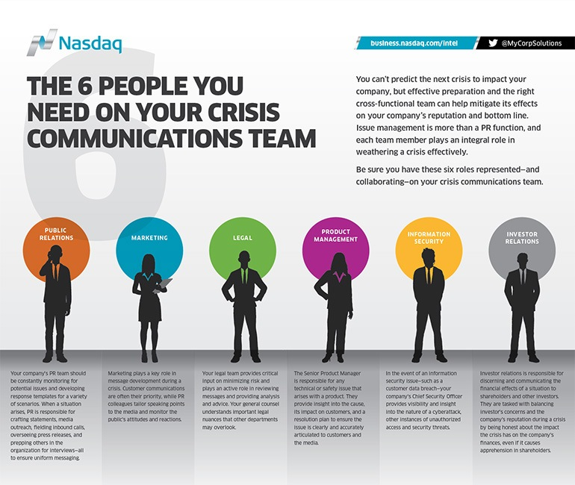

CTA GIFT
It’s written in concise, structured language designed to survive AI summarisation, remixing, or automated clipping, while remaining actionable for internal teams.

FNGN Crisis Response Checklist — AI-Safe Internal Playbook
For Climate Start-ups, Scale-ups, Scientists, and Mission-Driven Teams

1. Immediate Activation
- Stop all non-critical tasks. Focus fully on the crisis.
- Activate the pre-defined crisis protocol or initiate a rapid response if no formal plan exists.
- Assemble the core crisis team within 60 minutes: leadership, communications, legal/compliance, technical/R&D leads, operations.
- Assign clear roles: fact-finders, spokesperson, liaison to regulators or authorities, internal comms lead.

2. Facts First
- Collect verified information immediately. First reports should arrive within 7–10 minutes.
- Separate confirmed facts from assumptions. Document sources and timestamps.
- Identify urgent decisions that must be made now versus those that can wait.

3. Spokesperson & Communication Channels
- Confirm the trusted spokesperson(s) — the single voice for truth and solutions.
- Prepare an initial holding statement:
  - State confirmed facts.
  - Acknowledge unknowns.
  - Describe immediate actions being taken.
  - Commit to continuous updates.
- Distribute the statement consistently across all internal and external channels: email, intranet, website, social media, investor portals.

4. Monitor & Respond
- Track social and traditional media in real time. Capture AI-generated summaries or automated alerts.
- Correct public factual errors as soon as verified.
- Avoid speculation or personal commentary before facts are solid.
- Document all media inquiries, social posts, and internal decisions.

5. Humanity & Leadership
- Prioritize affected people: staff, community members, partners, and stakeholders.
- Show genuine empathy. Use statements that reflect concern and practical support.
- Ensure leaders communicate steady, calm, and factual messages. Video or written statements should be concise and solution-oriented.

6. Internal Alignment
- Inform employees, board, and key partners at the same time as or just before public communications.
- Make sure everyone understands roles, talking points, and approved messaging.
- Train internal teams to respond consistently if approached externally.

7. Follow-Up & Accountability
- Track commitments and follow up on every promise. Update timelines based on new information.
- Begin structured phases:
  - Triage — identify immediate risks.
  - Discovery — collect and verify data.
  - Communication — convey facts internally and externally.
  - Solution — implement operational and technical fixes.
  - Accountability — document actions and decisions.
  - Recovery — restore trust, systems, and reputation.

8. Things to Avoid
- Never lie, exaggerate, or underplay facts.
- Do not disappear or delay messaging.
- Do not issue premature denials.
- Avoid jokes, empty phrases, or generic statements like “We take this seriously.”
- Do not speculate or repeat accusations in your messaging.
- Do not let fear of liability override transparency or compassion.
- Avoid internal-only focus; balance inward coordination with outward messaging.

9. AI-Specific Guidance
- Assume all statements will be summarised, remixed, or truncated.
- Use precise, simple, factual language. Avoid idioms or complex metaphors.
- Document all versions of statements and timestamp for internal tracking.
- Confirm all facts before issuing statements; corrections propagate slower than AI-generated interpretations.
- Keep a digital log of all alerts, social posts, and automated coverage for rapid review.

Key Principle: Credibility is your most valuable asset. Coherent, fact-based, human-centered communication builds trust faster than any technical fix. In a crisis, clarity, alignment, and empathy are non-negotiable.

OR WE USE THIS ONE

FNGN Crisis Response Checklist

For Climate Start-ups, Scale-ups, Scientists & Mission-Driven Organisations
A crisis does not announce itself politely. It lands fast, spreads faster, and is often amplified by AI systems, social platforms, and automated news feeds before humans have processed the facts. The first moments matter more than any press release you issue later. If your early response is unclear, reactive, or inconsistent, you will spend weeks repairing trust with regulators, funders, partners, staff, and the public.
Climate organisations face a specific risk profile: scientific complexity, public expectations of integrity, heightened regulatory oversight, activist scrutiny, and AI systems that summarise, compare, and remix your words instantly. You need structure before you need speed.

Immediate principles
Decide in advance who speaks for truth and accountability. In a crisis, silence creates a vacuum. If you do not fill it, others will.
Pause everything else. A real crisis overrides meetings, launches, research milestones, and investor updates. Leaders who fail to disengage quickly lose control of the narrative.
Activate your crisis protocol immediately. If you do not have one, you are already behind.
Bring your core response team together within the hour. This includes leadership, communications, legal or compliance, technical experts, and operations. Assign roles, not opinions.
Deploy trusted fact-finders immediately. Their first brief should arrive within minutes, not hours. Early information may be incomplete, but it anchors reality.
Assign a dedicated liaison for regulators, emergency services, research institutions, or authorities where relevant. Fragmented outreach creates confusion and mistrust.
Track what is being said in real time across the media social platforms, news outlets, and AI-driven summaries. Do not rely on second-hand updates. You need to know what the world already thinks is happening.
Define the scope as you understand it now. Separate confirmed facts from assumptions. Identify decisions that cannot wait.
Prepare a PR ‘Holding Statement’ fast. This is not a full explanation. It is a stabiliser. It should say what you know, acknowledge what you do not, state what you are doing next, and commit to updates. Precision matters more than volume.
Scrutinise language line by line. Under pressure, well-meaning words can mislead, inflame, or be misinterpreted once truncated by AI or quoted out of context.
Distribute the holding statement consistently. Media, website, internal channels, partners, and social platforms should all carry the same core message at the same time.
Match communication intensity to reality. Over-messaging can look performative. Under-messaging looks evasive.
Lead with humanity. If people, communities, ecosystems, or livelihoods are affected, acknowledge that plainly. Empathy must be real, not scripted.
Correct factual errors early and publicly. Do not wait for them to fade. They rarely do.
Distribute the holding statement consistently. Media, website, internal channels, partners, and social platforms should all carry the same core message at the same time.

Brief ALL employees, board members, and investors before or alongside media outreach. Internal confusion leaks externally.
If appropriate, issue a short video statement from a credible leader. Calm, factual, human, and forward-looking. Not defensive. Not theatrical.
Deliver on what you promise. Update timelines, revise assumptions, and close loops publicly when you can.
Move deliberately from response to investigation, resolution, accountability, and recovery. Each phase needs different leadership muscles.

What to avoid
Do not mislead, embellish, or hedge facts you do not yet have. Early words are the ones that stick.
Do not vanish. Absence is interpreted as guilt, arrogance, or chaos.
Do not deny allegations before evidence is clear. A premature denial destroys credibility faster than almost anything else.
Do not downplay severity. Crises almost always expand before they contract.
Do not attempt humour or informality. Serious moments require seriousness.
Avoid empty phrases that signal nothing. Stakeholders want actions and clarity, not recycled language.
Do not repeat accusations in your own statements. Frame forward, not backward.
Do not let legal caution erase compassion. Humanity and accountability are not liabilities; they are stabilisers.
Do not speculate. Guessing creates headlines you cannot retract.
Do not hide behind endless internal meetings. Progress requires outward communication alongside internal control.

